РУССКИЙ ЯЗЫК 101
Хауэлл 2017

РАСПИСАНИЕ на неделю: 25.09.2017 - 29.09.2017

To prepare for Monday class, 25.09. Look at the Goals for Unit 2. Put a check by the ones you already have down, e.g. здесь / там (here- there); numbers 1-100 (write out the “decade” words again, and the teens); the conjugation of the verb жить (check!); about half the vocabulary you can use with confidence to label rooms, things in rooms, and family members.

Now start working on the still-to-be-accomplished goals.

By the end of this unit you will be able to:
- describe your own family and understand a short description of a family
- ask and tell using the adverbs "here" and "there" where people live
- label pictures of apartment rooms and furniture and give brief descriptions
- understand Russian addresses
- understand basic descriptions (young, old, new, big, small, etc.) and use them in statements and questions about people, places and objects
- understand and tell about a person's ethnicity (nationality) or national origin of an object
- show you know basic facts about the geography and ethnic makeup of the Russian Federation

To accomplish these outcomes, you will learn this information about the language:
- family member vocabulary
- words for adjectives and how to make them agree with nouns
- the conjugation of the verb жив-
- numbers from 0-100
- vocabulary for geographical features and parts of an address
- noun and adjectives referring to nationality, and when to use which one

To prepare for Tuesday class, 12.09

* Listen to the текст for 2.5 again. This is about Kaitlin's family in Kazan', how she thinks their apartment is nice but somehow manages to make a few statements that strike her хозяин (Марат Азатович Абудуллов) as very tactless.

1. AS YOU LISTEN ТО 2.5., have your BLUE book open and do the exercises on p. 64-65. Write in your answers, I’m going to check your books.

2. Review the information about Russian adjectives in немного о языке (2.5).

Adjectives have 2-vowel endings. Nouns have 0 (masc.) one-vowel (fem a, neuter o or e) endings. Adjectives come before the noun and they “agree” with that noun in number and gender.

Do exercises 2.5 Б. and B on p. 66. This is not hard, but it is totally crucial that you easily identify which adjectives “match” with which nouns in terms of number and gender.

3. Once you are solid on p. 66, you can do p. 67 and p. 68. BLUE HOMEWORK BOOK

In class: (bring blue homework book this time)

• how to make plurals (exception stressed “a” plurals for masculine nouns; normal “a” plural ending for neuter)
• check homework for accuracy, pp. 64-68
• give you a chance to describe your home and city outloud (exercises on p. 66)

To prepare for Wednesday class, 27.09

1. Listen to dialog 2.6. As you are listening (and looking at the words in the dialog! and scrolling over the bold ones to get the meaning!), do exercise A on p. 69 in your BLUE book.

2. Review all the pesky plurals, exercises Б В (p. 70-71)

3. Then do exercise 2.6 Д (p. 72), -- make sure you know how to sound complimentary! What a great room! What a nice kitchen! What beautiful windows! What interesting photographs!
use all these expressions, single and plural, as you would do in real life.

In class: We’re going to do the oral listening comprehension exercise, which you can prepare for by having listened to dialogs 2.5 and 2.6 (above) Then we’ll do the rest of the exercises for 2.6 together
  - start thinking about your FIRST ESSAY IN RUSSIAN, which you are going to complete on p. 75.

To prepare for Thursday class, 28. 09

1. See attached test prep sheets for oral and written part. We will take the test on MONDAY, so you have the weekend to practice reading outloud (see task #9 below), and to watch the nifty videos on Казань, Ярославль, Ст Петербург, атд. and look at a few maps.

2. For Thursday, listen to 2.7 and do the BLUE HOMEWORK workbook exercises (you can skip the annoying second one about unscrambling letters. Do the first one (p. 77) and all the exercises on p. 78.

Do the math on p. 79 (top).

In class: We’ll check all of the homework, practice for exam.

To prepare for Friday class, 29. 09

1. See attached test prep sheets for oral and written part. We will take the test on MONDAY, so you have the weekend to practice reading outloud (see task #9 below), and to watch the nifty videos on Казань, Ярославль, Ст Петербург, атд. and look at a few maps.

2. For Friday, listen to 2.8 and do the BLUE HOMEWORK workbook exercise for
2.8/ Б, В, Г, Е, И (“starting a composition”)

In class:

We will do the listening comprehension audio “наша семья довольно большая»
and go over all your homework, questions, etc.

Ideally, we want to have time to do the “color relativism” part at the end of the chapter, i.e. what connotations to “black,” “blue,” “pink” etc. have in Russian culture vs. American culture?

For the weekend: Make an appointment with Caroline Fernandez if you need help. Or study together.
To practice for the oral section, there is only one sure-fire way: imitate the dialog (2.6)

Parts of the test:

1. Listening comprehension: a short account of a family's new apartment (good prep is the activity in the homework 2.8 Ж). The address will include numbers.

2. Dictation: 2 sentences – containing adjectives, obviously! Pretty much as we've been doing in class nearly every day.

3. Word bank fill-in: complete a story (most likely a description of a house / apartment) with the words in the word bank above it. Homework exercise 2.8 Б is a good example. Make sure you know the forms of the verb жив- (live).

4. Family relationships: you see a family tree. Based on the visuals, write some sentences saying who several of the people are to one another: "Анна Петровна и Лена – мать и дочь"

5. Irregular masculine plurals ending in -а, regular plurals that have "fleeting vowels" (американец / американцы) and neuter plurals: on the test you will complete a short table consisting of singular and plural nouns of these types.

6. Parts of a house / apartment: label a drawing. Good review is to label everything you can, both rooms and furnishings, in this and other images in Unit 2 | 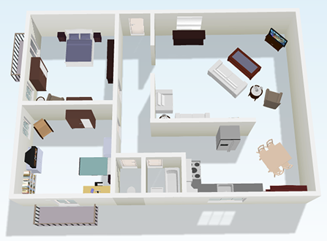

7. «What a large apartment!" / "This is our new apartment." / "The apartment is old."

8. Geography: you will, we guarantee, WILL have to label the following cities on a map IN RUSSIAN: St. Petersburg, Moscow, Yaroslavl, Kazan and Irkutsk. | 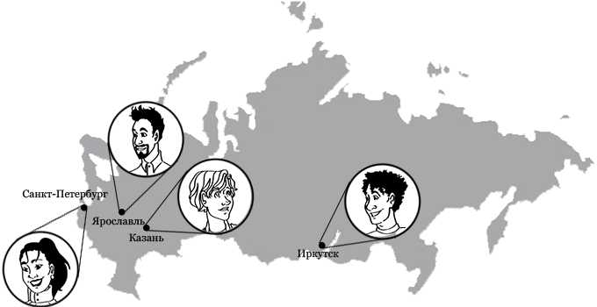

9. Speaking/Oral quiz: Pronunciation and Intonation.

Be prepared to read the following dialogue aloud. Pay careful attention to pronunciation and intonation as you read.

Ри́мма Ю́рьевна: Вас зову́т Ке́йтлин, да? Како́е интере́сное и́мя! Э́то на́ша кварти́ра, Ке́йтлин. И кварти́ра но́вая, и дом но́вый. Э́то на́ша больша́я ко́мната.
Ке́йтлин: Кака́я интере́сная фотогра́фия! Э́то вы?
Ри́мма Ю́рьевна: Да, э́то мы.
Ке́йтлин: Вы здесь таки́е молоды́е.
Мара́т Аза́тович: А что, мы сейчас ста́рые?
Ке́йтлин: Нет, нет, что вы!
Ри́мма Ю́рьевна: Здесь мы студе́нты, как вы сейча́с. Да, мы молоды́е.

You know what русский means. What do you think язык means? a) class b) language c) tongue d) both a) & b) e) both b) & c).
Whose name is this? Can you transliterate it back into English?
You will see this word a lot. Technically, it consists of a prefix рас (ras -) + a root word пис (pis-) + a suffix with a typical soft neuter noun ending, i.e. –ие. The root has to do with “writing” or “scribing” (as in prescribe, describe, inscribe … ) So in Russian, our word for “schedule” is roughly “writing-it-out” = расписание.
What do you notice about writing the date in Russian (and all over Europe, even Britain!). Remember that only Americans write month/day/year; everyone else writes day.month.year.

