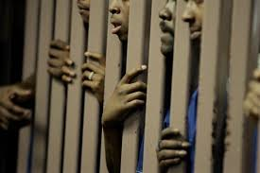

PLSC 323: MONEY, POLITICS, AND PRISON
FALL 2023
Monday and Wednesday, 10:30-11:45 am
Jepson Hall, Room 108
Dr. Andrea Y. Simpson, Instructor
Office: Weinstein Hall, Room 202K
Office Consultations by Appointment Only
804.289.8739-office phone
asimpson@richmond.edu

The United States imprisons more of its citizens than any other nation in the world. We spend about 182 billion dollars a year to incarcerate nearly one percent of our population. Whites are underrepresented in the system, while Blacks, Latinos, and other minorities are overrepresented. Why do we incarcerate so many of our own citizens? Are more of us prone to break laws than citizens in other countries? Is incarceration always the best answer to a violation of the law? How does the use and sale of illegal drugs affect the numbers of prisoners? These questions and more guide our studies this semester. We will also visit at least two state prisons this semester.

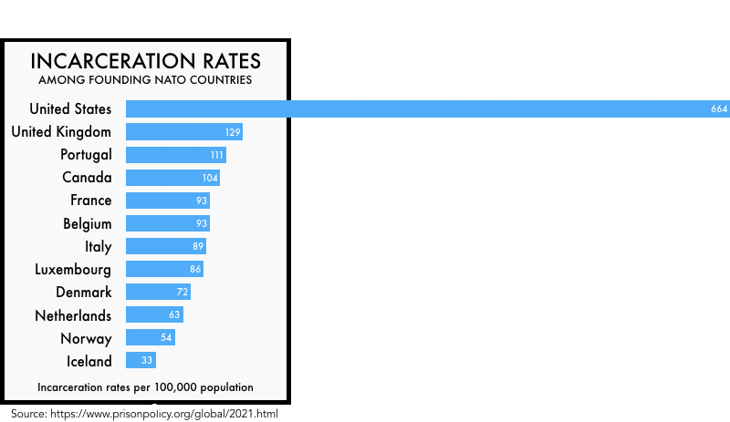

COURSE REQUIREMENTS

Readings

Books

Are Prisons Obsolete? The Sun Does Shine
Angela Davis Anthony Ray Hinton
Penguin Random House St. Martin’s Press

Writing my Wrongs
Shaka Senghor
Convergent Books

Articles as assigned are available on the blog.

Grading and Assignments

Response Papers-Two 1 to 1.5 responses to readings. %20
Participation: 25%
Presentation: 25%
Midterm: 30%

Paper Assignments

Response Paper-The response papers of 800 words on one of the readings or documentaries. Following is a description of the kind of response paper expected:

- This is a textual response paper.
- You do most of the work on the front end—decide on the reading and the topic of your paper.
- What is the theme that prompts your response?
- It always helps to do an outline to connect the points you want to make.

Below is a website that can help you write this kind of paper:

https://www.rhulisc.com/blog/how-to-write-a-reflection-paper

In-Class Participation

“A” for class participation is awarded when students regularly initiate discussion. This means coming to class thoroughly familiar with the assigned reading and, therefore, prepared to raise questions, to open discussion, to identify topics of interest in the reading, and actively engage other students in the discussion. The quality of your blog posts matters. Do your comments expand on the readings or point out interesting aspects? Did you do any additional research to expand on your points? [90-100 points]
“B” for class participation is awarded to students who participate regularly and productively in class discussion, who are prepared, and who are willing to engage. Students who earn “Bs” differ from “A” students in that the latter are self-starters who do not rely on the instructor's questions to set the agenda for discussion. [80-89 points]
“C” for class participation is awarded to those who participate on a regular, but less frequent basis than the B student. Students who earn “Cs” arrive prepared for class, but their contributions will indicate that less thought has been given to assigned materials. [70-79 points]
“D” for class participation is given to those who contribute infrequently to the discussion and whose contributions do not appear to arise from thoughtful consideration of the assignments. [60-69 points]
“F” for non-participation in class discussion. Of course, participation is impossible if you do not attend class. Frequent absences mandate failing grades. [0-60 points]

Discussion Board on the Blog

Discussants for each week will post main points and questions on the blog by Tuesday evening at 7 pm. Each student will respond to the questions and comments by the discussants and other class members after class. All comments should be posted by the end of the week (Friday).

Writing Expectations

My standards for writing are rigorous. I will assess your writing based on clarity, organization, word usage, and sentence construction. You should have a clear understanding of baseline standards in these areas. I plan to carefully edit each assignment, including in-class writing assignments, for spelling, punctuation, and grammatical mistakes. I strongly recommend that you purchase a good writing book. My favorite tools are On Writing Well, by William Zinsser and Woe Is I by Patricia T. O’Connor. Other excellent writing tools are Eats, Shoots, and Leaves: The Zero Tolerance Approach to Punctuation by Lynn Truss and Elements of Style by William Strunk, Jr.
Remember that running a “spell check” through your Word program is not the same as proofreading your work. Many writers find it helpful to read their papers aloud, especially to others, to find errors of sentence construction and logic. Please seek help from the Writing Center and other resources listed on the blog. I am available for consultation via email and by appointment. Following are a few tips:

- Personal experiences and observations do not carry as much weight as an academic publication. Anecdotes and stories can illuminate, but they are no substitute for hard research, whether it is qualitative or quantitative.
- Avoid the temptation to write something you think I will agree with—you cannot be sure of my opinion in this class. During many classes, I will play “devil’s advocate” to spark discussion and to help you to think more critically. Integrity in writing includes writing about something that you believe in, not something that you believe can yield extra points from the professor.

Discussion Board on the Blog-Posting on the blog is part of your participation grade.

Discussants for each week will post about 500 words main points and questions on the blog by Friday evening at 5 pm. Each student will respond to the original post with about 500 words. All comments should be posted by Sunday at 5 pm.

In-Class Exercises

In-class exercises/quizzes and homework cannot be made up for any reason. No assignments will be accepted after class on the due date except by prior arrangement or in the case of authentic, verifiable emergency. If a student does not turn in an assignment on the due date and has not planned with the instructor beforehand, the student will receive a “0” (zero) on that assignment. Late assignments are docked one letter grade for each class day late. After four late days, a late assignment will automatically be given a zero. After a grade is returned, students have one week to resolve questions about the grade with the instructor. Questions about a grade must be submitted first in writing. After one week, the grade is final.

Late Work

Turning in late work reflects poorly on you. Please avoid it at all costs. Any late work receives a letter grade deduction for each class period it is late.

Attendance

Students are responsible for all information in the class, regardless of their personal attendance. If a student is absent, it is his or her responsibility to inquire about what they have missed. Absences due to university activities (e.g., sports, mock trial, etc.) must be discussed with the instructor before the relevant class period(s). An official notice must be shown to the instructor. Arrangements concerning absences are entirely at the instructor's discretion.

Please be on time for class to avoid unnecessary disruptions of speeches, lectures, and discussions.

You may need your laptop, tablet, or other device to take notes or to do in-class research. We will also do a lot of class discussion, so please be ready for us to ask you to put your screens away.

Grievance Procedures

Occasionally, students are unsatisfied with some dimension of the course. In such cases, you should first provide a written argument in support of your position to the instructors and request a meeting. All grade appeals on specific assignments must be made within one week of the return of the assignment.
**Any students who need accommodations for learning or who have needs are invited to share these concerns or requests with the instructors as soon as possible.

Academic Honesty: Pledging

Our understanding of AI tools (like ChatGPT) is constantly evolving. While we may explore these technologies in class, you are prohibited from using these tools to complete course assignments unless I have explicitly asked you to do so. Unauthorized use of these tools will be considered an Honor Code violation in this class.

Students are expected to pledge the following statement on all assignments turned in for credit, including exams, papers, and laboratory reports: "I pledge that I have neither received nor given unauthorized assistance during the completion of this work." Academic honesty is—defined broadly and simply—the performance of all academic work without cheating, lying, stealing, or receiving assistance from any other person or using any source of information not appropriately authorized or attributed. The University of Richmond and your professors take academic honesty very seriously. The penalties for academic dishonesty are severe and ignorance is not an acceptable defense.

Students are expected to pledge the following statement on all assignments turned in for credit, including exams, papers, and laboratory reports: "I pledge that I have neither received nor given unauthorized assistance during the completion of this work." Academic honesty is—defined broadly and simply—the performance of all academic work without cheating, lying, stealing, or receiving assistance from any other person or using any source of information not appropriately authorized or attributed. The University of Richmond and your professors take academic honesty very seriously.

All students are responsible for maintaining the highest standards of honesty and integrity in every phase of their academic careers. The penalties for academic dishonesty are severe and ignorance is not an acceptable defense.
For more information visit:

http://studentdevelopment.richmond.edu/student-handbook/honor/the-honor-code.html

Use of ChatGPT and Artificial Intelligence Software

In your written assignments for this course, all work you submit must be entirely your own. Words, sentences, paragraphs, and essays which are the product of AI software, for example, may not be presented as your own work, and doing so is a violation of university policy. As a learning community, we might find ways to use AI to generate thoughts or as a starting point for honing critical thinking skills.

Part of this statement is reprinted with permission from Dr. Tony Affigne, Professor, Providence College.

COURSE SCHEDULE*

August 28 Introduction, Syllabus review, assignment of readings

August 30 Read: “Hustle and Flow: Prison Privatization Fueling the Prison Industrial
Complex”, by Patrice Fulcher
Discussant: Prof. Simpson

September 4 Read: Chapters 1-3: Are Prisons Obsolete? Angela Y. Davis
Discussant: ProfSi

September 11 Read: Chapters 4-6: Are Prisons Obsolete? Angela Y. Davis
Discussant: SARA

September 13 Read: “From the Philadelphia Negro to the Prison Industrial Complex: Crime and the Marginalization of African American Males in Contemporary America, Owen Brown.
Discussant: WILL

September 18 Read: “Race, Gender, and the Prison Industrial Complex: California and Beyond”
Davis and Shaylor
Discussant: MAR

September. 20 Read: “The PIC: A Growth Industry,” Heather Thompson
Discussant: VICTORIA

ON MONDAY, 9/25, WE WILL HEAR FROM WILL, MAR, AND VICTORIA ON THE READINGS. THIS FRIDAY, 9/22, MAR, VICTORIA, AND CHERYL NEED TO POST AND STUDENTS, YOU NEED TO ANSWER ALL POSTS BY SUNDAY, 9/24, AT FIVE. IT SHOULD NOT BE DIFFICULT SINCE THESE READINGS ARE RELATIVELY EASY. CHERYL, YOU ARE POSTING BECAUSE YOU PRESENT ON WEDNESDAY.

September 27 Read: “The Racialization of Crime and Punishment,” Brewer and Heitzeg
Discussant: CHERYL

TBA “End of the Line: Tracing Racial Inequality from School to Prison,” Lizbet Simmons
Discussant: EMMA-WE WILL GET TO THIS AFTER SPRING BREAK.

FIRST RESPONSE PAPER DUE TODAY, 9/27/23

Octobr 2 Field Trip to State Farm Correctional Institution

October 4 Field Trip to Fluvanna Correctional Institution

October 9 REVIEW FOR MIDTERM EXAM

October 11 MIDTERM EXAM IN CLASS—PLEASE BRING YOUR LAPTOPS

FALL BREAK: OCTOBER 13-OCTOBER 17

October 18 Read: Chapters 1-4, Senghor, Writing My Wrongs
Discussant:

October 23 Read: Chapters 5-10, Senghor, Writing My Wrongs
Discussant:

October 25 Read: Chapters 11-14, Senghor, Writing My Wrongs
Discussant:

October 30 Read: Chapters 15-18, Senghor, Writing My Wrongs
Discussant:

November 1 Read Chapters 19-21, Senghor, Writing My Wrongs
Discussant:

November 6 Read Chapters 22-26, Senghor, Writing My Wrongs
Discussant:

November 8 Read: Chapters 1-8, Hinton, The Sun Does Shine
Discussant:

SECOND AND FINAL RESPONSE PAPER DUE TODAY, NOVEMBER 8, 2023

November 13 Read: Chapters 9-16, Hinton, The Sun Does Shine
Discussant:

November 15 Read: Chapters 20-25, Hinton, The Sun Does Shine
Discussant:

November 20 Read: “Using History to Make Slavery History”
Discussant:

THANKSGIVING BREAK: NOVEMBER 21 through NOVEMBER 26

November 27 Read: “If Orange Is the New Black, I Must Be Color Blind: Comic Framings of Post-Racism in the Prison- Industrial Complex,” Enk and Morrissey
Discussant:

November 29 Read: “The Future of the Global Prison Industrial Complex,” Mary K. Ryan
Discussant:

December 4 The House I Live In

December 6 Complete The House I Live In- What have we learned?

