WGSS 200: Introduction to Women, Gender, and Sexuality Studies
Spring 2021
Online Only
https://blog.richmond.edu/introwgss/
Andrea Y. Simpson, Instructor
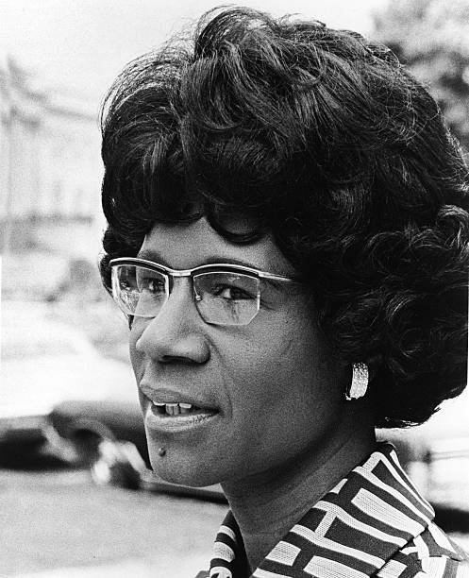
Office Hours: Zoom Meetings by Appointment Only
Email: asimpson@richmond.edu

The emotional, sexual, and psychological stereotyping of females begins when the doctor says, "It's a girl."-Shirley Chisholm

Why do we study the societal implication of humans categorized as women, men, queer, gay, lesbian, bisexual, or transgendered? What questions are being asked, and answered, by scholars in this field? Why should we care? This semester, we will read, discuss, and learn together about the power of identity and the struggle for equal rights and agency by people who are categorized in these groups.

Learning Goals

- Students will be able to explain the history and theoretical evolution of feminist thought
- Students should understand intersectionality as a theoretical field and a research tool
- Students should understand how race interrupts the establishment of a static identity as “women”
- Through the digital portfolio, students will be able to take others through ideas, topics, issues, or events, that are organically connected to our subject through gathering readings and a variety of media.

COURSE REQUIREMENTS
ATTENDANCE
Students are required to attend every class, since participation is a significant part of assessing your performance in the class, I will occasionally have short writing assignments in class. If you are not there, you cannot complete the assignment. I will excuse students in cases of illnesses and family emergencies. It is important that students contact me before the class meeting missed. I report excessive unexcused absences to the appropriate Dean’s office.
Your Instructor: Andrea Y. Simpson, Ph.D. (ProfSi)
I am in my 17th year of teaching in the Department of Political Science at the University of Richmond. I study and write about Black politics, environmental justice, and intersectionality. I received my master's degree from the University of Virginia, and my Ph.D. from Emory University.

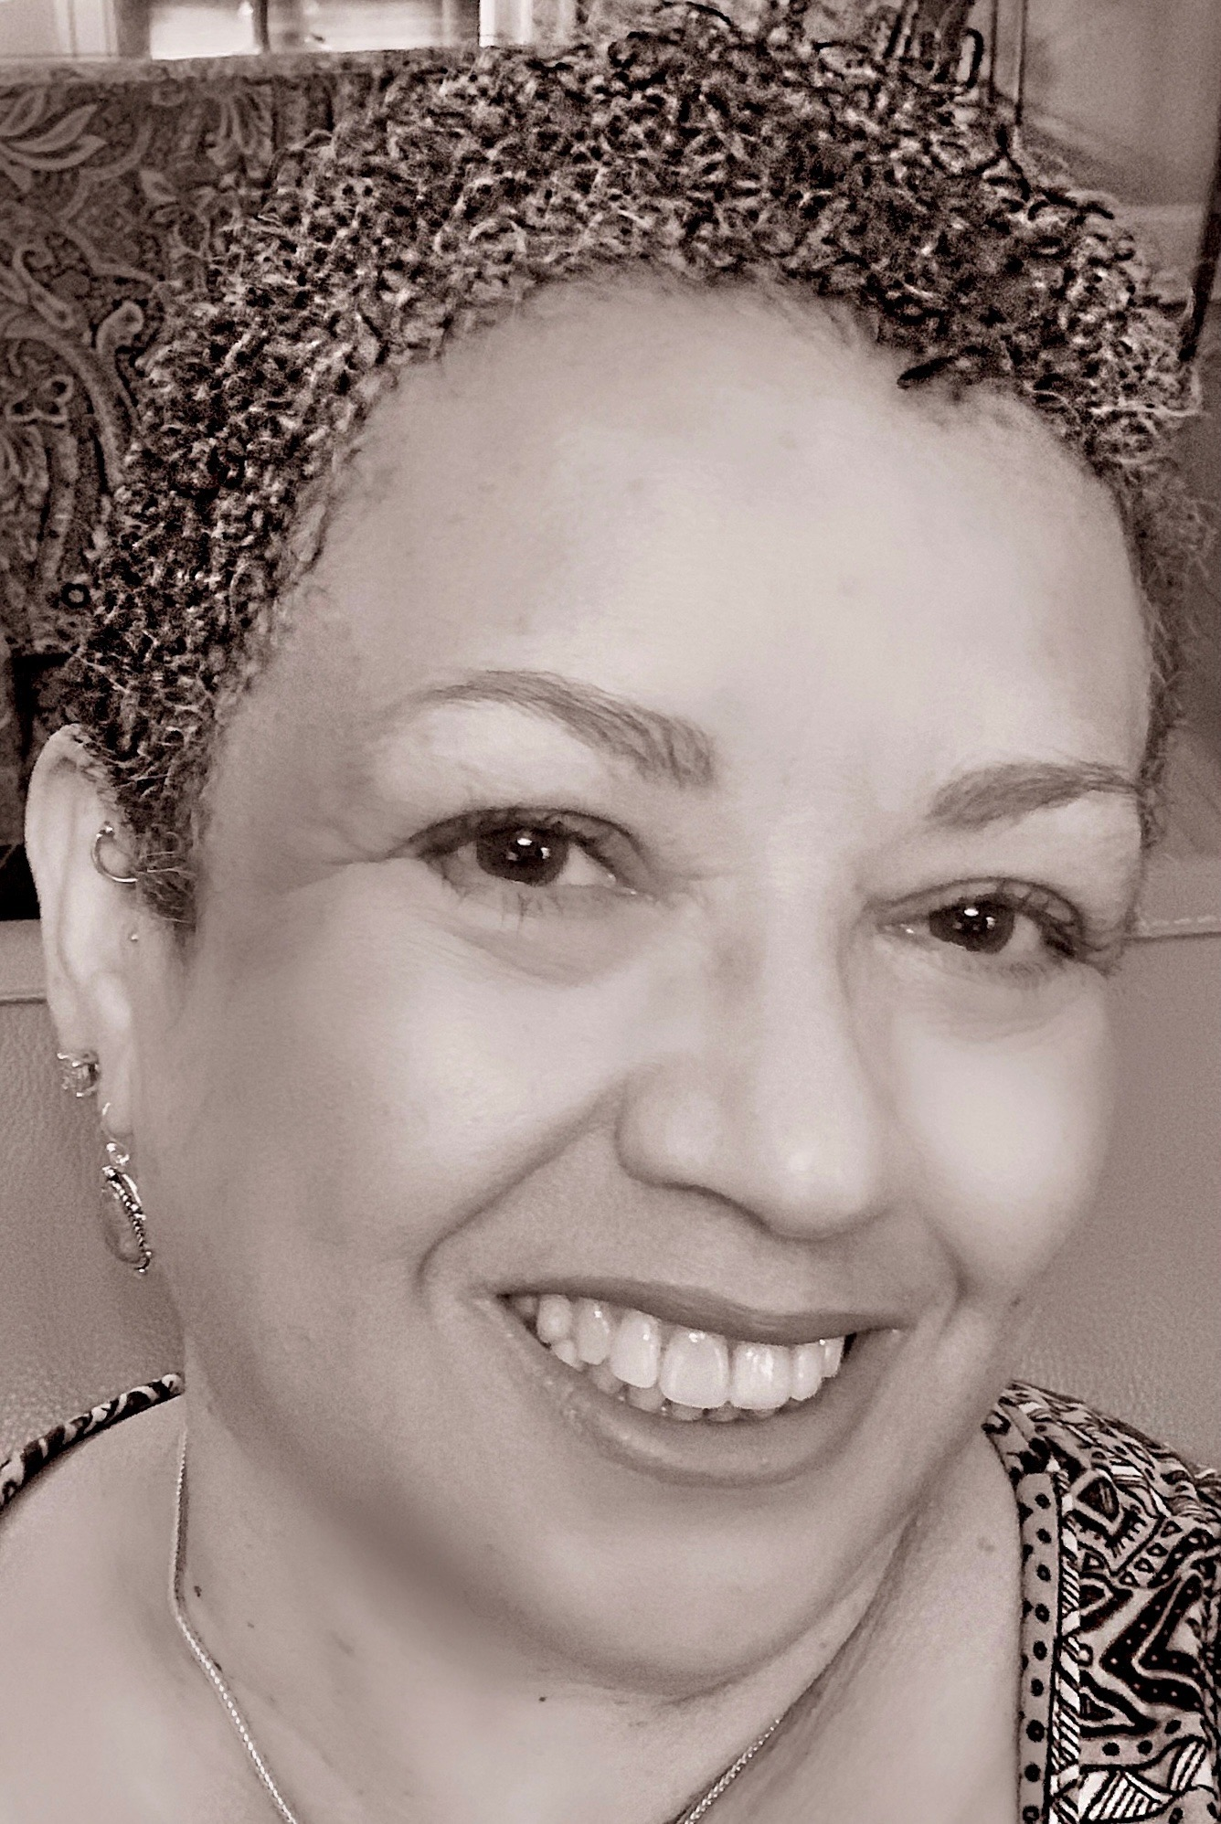

ASSIGNMENTS
Think Pieces
During the course of the semester, you will write three “think pieces” in response to readings and in preparation for discussing them. They should be 2-3 pages in length and include citations if necessary. No late papers will be accepted.
Purpose of the Think Pieces:
- as a tool for analyzing a text quickly and thoughtfully
- tease out key ideas in a format that gets to the heart of your response.
- to critically read and discuss ideas
- bring an analytical lens to our current understandings of various theories about gender, sex, and intersectionality
- present our analysis, beliefs and ideas in structured, clear and concise writing.
Curation of Readings
Each week one or two students will be assigned to curate the readings for the next week. By curation, I mean that you will post a summary of the reading on our course blog in the Discussion Section, and pose questions for our consideration. You might also include links to different forms of media—YouTube clips or magazine articles that will illuminate the readings for us. Each summary should be 750 words. Each student must post a response of at least 250 words to the questions, and the curators must respond to them in 250 words or less.
IMPORTANT: The curators’ post for Tuesdays must be up on the class blog by Saturday at 9 pm. If you are curating for Thursday, your post must be up by Sunday at 9 pm. The curators’ posts should be about 750 words. Students must respond by Monday at 9 pm for the material for Tuesday, and by Wednesday at 9 pm for the readings scheduled for Thursday. Student responses should be about 250 words. Curators should monitor the discussion board and respond to some of the posts.
Digital Portfolio
A digital process portfolio is your project for the course. The purpose is to help you reflect on course materials and discussion. It is designed to be a learning tool and an assessment tool. Since your think pieces are just three pages in length, the portfolio offers the opportunity to expand on that work. You can insert video clips, more writing, news articles, artwork, music, and journal entries. It can be anything that you want it to be.
We will discuss in class what platform might be best to use. A rubric is on our class blog, so be sure to check regularly for extra articles and other resources.

Honor Code
Students must adhere to the University of Richmond Honor Code. This means that on both the midterm and final exam, students must write the following, “I pledge that I have neither given nor received assistance during the completion of this work.” You should provide your signature after the pledge.
Students are encouraged to seek help in writing papers. However, it is a violation of the honor code to plagiarize content from any source. Plagiarism is the act of using someone else’s words without proper attribution. Paraphrasing does not exempt students from the need to cite sources. Please refer to the University of Richmond websites at http://www.richmond.edu/about/features/honorcode.htm and http://writing2.richmond.edu/writing/wweb/source.html for additional guidance.
Creating an Inclusive Learning Community

The college classroom works best when we treat each other with care and respect. We represent a variety of backgrounds and perspectives. The Women, Gender, and Sexuality Studies program is founded on principles of equity and inclusivity. As we build this community, we must practice the following:

Share our experiences, values, and beliefs.
Be open to the views of others.
Appreciate the uniqueness of our colleagues.
Resist the temptation to dismiss each other’s opinions.
Keep confidential any expression of a personal (or professional) nature.

Grading Distribution:

25% Participation: Discussion posts and responses, and class participation.

30% Writing: Two three-page think pieces.

20% Exam: Midterm

25% Final Project: Digital Portfolio and Presentation

Texts and Readings
Feminist Theory: From Margin to Center, 3rd Edition, bell hooks
Men Explain Things to Me, Rebecca Solnit
Women, Race, and Class, Angela Y. Davis
Thick, Tressie McMillan Cottam
All articles are available online at our blogsite at https://blog.richmond.edu/introwgss/

GENERAL COURSE GUIDELINES
- All assignments are accepted during class on, or before the due date only. There are no make-up exams. Please submit course assignments to me at asimpson@richmond.edu.
- All work must be typed in 12-point font and adhere to MLA or Chicago format style.
- Submitted work is only accepted via email and before class on the due date.
- Attendance will be taken. Take note of the following:
- If you are absent:
You are responsible for any materials you miss during a regular class meeting, including assignments given in your absence. If you miss class, get notes from a classmate and ask any questions about the missed lecture before the next class meeting. While I will not repeat lecture material, I will answer questions of clarification.
- If you are absent on a day when an assignment is due, it is your responsibility to get the assignment to me by class time in order to earn credit for the assignment.
- If you are absent during an in-class assignment, you cannot make up those points.
- Arrive to class on time. Excessive tardiness will be reflected in your final grade.
- Consistent attendance and timeliness will be weighed into your final grade.
- If you have a documented disability and require any accommodations, please let me know immediately so that your learning needs can be met in a timely manner.
- Engage openly and respectfully during class discussions. We will examine ideas that may challenge your ways of being and knowing. I ask that each of us critically examine all beliefs. Feel free to challenge ideas openly, but focus on the argument. As you engage in class, you may not use discriminatory language.
- Remember the following:
- Take responsibility for your own learning. Ask questions, complete assignments on time, arrive to class on time, and solicit any help you may need in a timely manner. If you need something from your classmates or me, let us know so that we can create an optimal learning environment.
- Feel free to challenge ideas. All ideas are open for questioning, but the person who asserts, must support her/his argument(s).
- Don’t take critical dialogue personally. My philosophy of education includes the belief that we are here to learn about ideas, how to argue in favor of our ideas and how to raise our consciousness.
All cell phones must be turned off prior to entering the virtual classroom.
Standards
A Range: Excellent work. Your work thoroughly surpasses the minimum requirements. You have gone above, and beyond the call of duty, presenting interesting, compelling and rigorous work. The arguments made are strong, well thought out and effectively supported. You show a clear grasp of the material, are able to effectively interpret and critique the material, and extend it beyond its basic applications. The class learned something valuable from you.
B Range: Very good work: You have done more than was required on the assignment and have no more than one or two minor problems with the work. The arguments are somewhat strong, but lack some necessary support. You show that you know the material and understand it; however, more work on application, interpretation and critique is needed to move the assignment into the A range.
C Range: Average work. You have done what was required of you competently with only a few minor problems. The arguments are basic and meet the minimal requirements for effective argument. You show that you are familiar with the material and reflect your understanding, ability to apply, interpret and critique the material at a basic level.
D Range: Below average. You have done less than the minimum requirement with many minor problems and/or one major problem. The arguments are seriously lacking in organization and support. You do not demonstrate your knowledge of the material and there is no evidence of application, interpretation and critique.

COURSE SCHEDULE
MODULE 1: What does a feminist look like? Origins and Waves of Feminism

Week 1

DATE | READING/VIEWING | CLASS AGENDA
Tuesday, 1/19 | Butler, “The Backlash Against Gender as Ideology Must Stop” | Introductions, Review of Syllabus, Discussion of Butler Piece
Thursday, 1/21 | Hooks, Chapters 1-3 | Discuss Chapters-Assignments for Curators
Notes: Simpson is the curator this week.

Week 2

DATE | READING/VIEWING | CLASS AGENDA
Tuesday, 1/26 | Hooks, Chapters 4 and 5 | Discussion of Readings
Thursday, 1/28 | Hooks, Chapters 6 and 7 | Discussion of Readings
CURATORS: NICOLE BURNEY & CHRIS BARRY

Week 3

DATE | READING/VIEWING | CLASS AGENDA
Tuesday, 2/2 |  | Discussion
Thursday, 2/4 |  | Group Discussions-What Have We Learned

Module 2: Contemporary Concepts in Feminist Discourse-Feminism Turns Its Gaze to Masculinity

Week 4

DATE | READING/VIEWING | CLASS AGENDA
Tuesday, 2/9 | NO CLASS TODAY | NO CLASS TODAY
Thursday, 2/11 | “Feminists: What Were They Thinking”-Documentary | Take notes.  Link: https://www.netflix.com/title/80216844  Discussion: What were feminists thinking? What do you think?
No Curators
Week 5

DATE | READING/VIEWING | CLASS AGENDA
Tuesday, 2/16 | Hooks, Chapters 8, 9  Hooks, Chapters 11 and 12 | Discussion  Reflection on Documentary: Questions?
Thursday, 2/18 | Solnit, Chapters 1 through 5 | Discussion
CURATORS: TAMAR ACCIUS & ZAY WILSON-hooks ONLY
CURATORS: RACHEL MATTHEWS & CLAIR PAULHAC

FIRST THINK PIECE DUE ON THURSDAY, 2/18 BY 11 AM

Week 6

DATE | READING/VIEWING | CLASS AGENDA
Tuesday, 2/23 | Solnit, Chapters 6-8 | Discussion
Thursday, 2/25 | Solnit, Chapters 9 | Discussion
CURATORS: MARIA PERRY &  JUDITY WITKE-MELE | Notes: Ideas for Portfolios Due Next Week

Week 7

DATE | READING/VIEWING | CLASS AGENDA
Tuesday, 3/2 | Prepare for Midterm | Have your questions ready regarding concepts, historical events, that you need to know more about or do not fully understand.
Thursday, 3/4 | Midterm-Sent via Email | You will have access at 11 am must email it back to me no later than 1:00 pm. These are hard deadlines.
NO CURATORS

Module 3: Intersectionality

Week 8

DATE | READING/VIEWING | CLASS AGENDA
Tuesday, 3/9 | Watch: “Out in the Night”  https://richmond.kanopy.com/product/out-night-criminalization-race-gender-iden | Take notes. Try to connect the events to what we have been reading and discussing in class.
Thursday, 3/11 | Davis, Women, Race, and Class-1-4 | Discussion
CURATOR: MAMIE ZIEGLER- ONLY FOR THURSDAY

Week 9

DATE | READING/VIEWING | CLASS AGENDA
Tuesday, 3/16 | Davis, Chapters 5-8 | Where have we been? Where are we going? Where are we with our portfolios?
Thursday, 3/18 | Davis, Chapters 9-13 | Discussion-How does Davis’s work compare to the other two texts.
CURATORS: AMARA TAYLOR & SARAH NGUYEN

Week 10

DATE | READING/VIEWING | CLASS AGENDA
Tuesday, 3/23 | Cottom, Thick, Chapters 1-4 | Discussion
Thursday, 3/25 | Cottom, Thick, Chapters 5 and 6 | Discussion
CURATORS: SAL KOUREISSI & ANYA DINH

SECOND THINK PIECE DUE ON THURSDAY, MARCH 25 AT 11 AM
Week 11

DATE | READING/VIEWING | CLASS AGENDA
Tuesday, 3/30 | Cottom, Chapters 7 and 8 | Discussion
Thursday, 4/1 | Understanding Intersectionality  Read: Ernst, et. al, “Citizen Control at the Welfare Office”
CURATORS: YARI CORREA & POLINA SHITIKOVA

Module 4: Performing Masculinity-What does it mean?

Week 12

DATE | READING/VIEWING | CLASS AGENDA
Tuesday, 4/6 | “Knock Down the House”-View | Take Notes
Thursday, 4/8 | Read:  Shields, “Gender: An Intersectionality Perspective”  Bilge, “Intersectionality Undone: Saving Intersectionality from Feminist Intersectionality  Studies” | What do we think about AOC and her sister-representatives? How does gender direct the response of people, media, ourselves?
CURATOR: SHIELA MAE MARTINEZ FOR THURSDAY ONLY

Week 13

DATE | READING/VIEWING | CLASS AGENDA
Tuesday, 4/13 | Go Over Our Portfolios-What aspects of the class were most meaningful for you? | Discussion
Thursday, 4/15 | Presentations

Week 14

DATE | READING/VIEWING | CLASS AGENDA
Tuesday, 4/20 | Presentations
Thursday, 4/22 | Presentations

Week 15

DATE | READING/VIEWING | CLASS AGENDA
Tuesday, 4/27 | Presentations
LAST DAY OF CLASS

https://canvas.brown.edu/courses/202417/pages/writing-assignment-number-1-think-pieces
http://www.edutopia.org/blog/11-essentials-for-excellent-eportfolios-vicki-davis

