Sustainably Selective? Understanding and Improving Selective Logging in the Peruvian Amazon

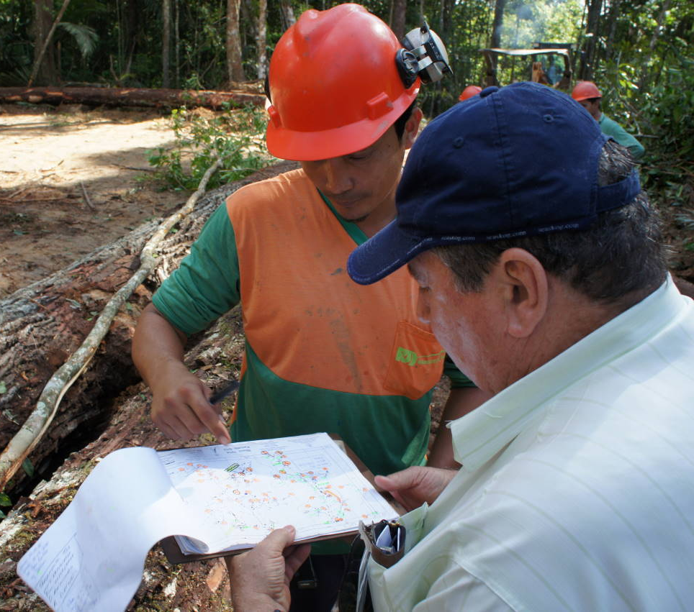
(Kopp, 2011)

CC
Forestry Assessment Report Paper
Society, Economy, and Nature
Table of Contents
I. Introduction……………………………………………………………………………3

II. Methods……………………………………………………………………………….5

III. Selective Logging Practices: Literature Review and Summary………………….6

IV. Impact of Physical Geography on Selective Logging………………………….…11

V. Environmental Impacts of Selective Logging……………………………………...13

VI. Improvements to Logging and Forestry Management in the Peruvian Amazon………………………………………………………………………………….15

VII. Conclusion………………………………………………………………………....20

VIII. Bibliography……………………………………………………………………...22

I. Introduction
When many people think of logging in the Amazon, they picture huge swathes of clear-cut land that destroys the rainforest and its charismatic megafauna. These stark and destructive images fuel the belief that the only way to save rainforest biodiversity is to stop logging completely (Putz et al., 2000). In reality, however, most rainforest logging operations do not occur at the scale or intensity of clear-cutting, and many communities rely on logging operations for their livelihoods. Many logging operations instead practice selective logging, a technique in which small teams of loggers venture into forest tracts to harvest only the most commercially valuable species (Anser et al., 2005). Though selective logging is less environmentally destructive than clear-cutting, its widespread use is threatening biodiversity and sustainable timber yields basin-wide (Putz et al., 2000; Putz et al. 2008; Fredericksen & Putz, 2003; Barros & Uhl, 1995). Sustainable logging practices, however, have been shown to mitigate some of these environmental damages and improve long-term profitability of logging operations, therefore benefiting both the environment and local communities (Putz et al., 2008).
High demand for exotic woods, exhaustive logging in Asia, and the depletion of timber stocks in southern Brazil has increased selective logging operations throughout the Amazon Basin (Uhl et al., 1991). The Peruvian Amazon was once one of the more isolated regions in the Amazon Basin, but the economic incentives of harvesting commercially profitable timber has intensified selective logging operations in the area. Encompassing most of Peru east of the Andes Mountains in the provinces of Loreto Ucayali, and Madre de Díos (Figure 1), the Peruvian Amazon has important ecological and economic functions (Pearce et al., 2003). The Peruvian Amazon forest provides timber and non-timber resources for local communities, is home to much of the world’s biological diversity, and serves as a regulator “of local, regional, and global environments” (Pearce et al., 2003). The regional capitals of Iquitos, Pucallpa, and Puerto Maldonado serve as important gateways into the Peruvian Amazon, as the isolated nature of the area means little infrastructural development had reached the small local communities and indigenous populations that call the Peruvian Amazon home (De la Rosa Tincopa, 2009; Salisbury, 2009).
This once isolated region has been distinctly impacted by the unrestricted and widespread use of selective logging. In its current form, however, selective logging is ecologically damaging, unsustainable, and economically wasteful (De la Rosa Tincopa, 2009; Salisbury, 2009; Putz et al., 2008; Holmes et al., 2002). The future success of forest management in the Peruvian Amazon depends on a creating an approach that balances the relationships between ecological, economic, and social interests. In order to understand effective techniques that may be used to develop an integrated forestry management system, it is important to understand how selective logging is currently used in the Amazon and its impacts. While governance norms and political economy play large roles in selective logging, this study will focus on how improved ecological data collection, better understanding of the Amazonian ecosystems, and local community participation, may help create an efficient and effective forestry management system that integrates and benefits all interests.
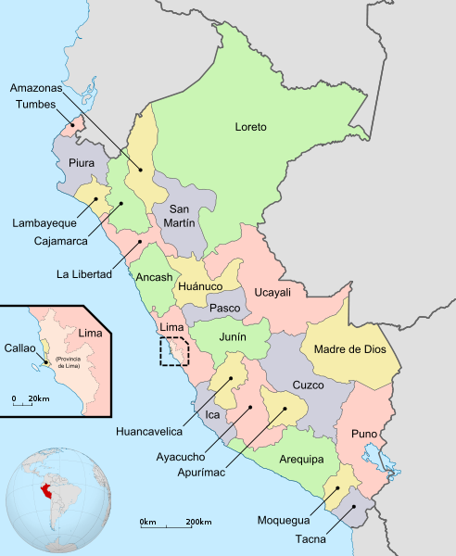
N
Figure 1. The Peruvian Amazon (light green, coral, and yellow regions circled in red) is located in the eastern part of the Peru. The regional capitals of Iquitos and Pucallpa are important gateways into the rainforest. (Map: Huhsunqu, 2009)
II. Methods
The complexity of the issues surrounding logging and forestry management in the Peruvian Amazon affects, and is affected by, multiple, diverse sources and systems. In order to understand factors that drive and influence logging in the Peruvian Amazon and how to move the logging system towards a more sustainable future, it is necessary to tackle the issue from many different angles. The Forestry Assessment Report (FAR) project developed in Dr. Salisbury’s Society, Economy, and Nature class at the University of Richmond, Richmond, Virginia, was designed to compile informative, analytical research on the topics the class determined to be most important to understanding and improving the logging system in the Peruvian Amazon.
The class was split into groups according to five core themes: local livelihoods, governance, structure, norms, and ecology and management. From there, groups brainstormed to develop individual papers exploring different topics of each theme. These divisions allowed the class to investigate many different aspects of the Peruvian logging system, with guidance from overarching and uniting themes. This particular paper discusses current selective logging norms, as well as how sustainable forestry techniques can be used to improve the logging system, as part of the ecology and management section.
Thorough research on current selective logging practices, as well as research on sustainable forestry techniques was needed to develop a full understanding of the state of selective and sustainable logging in the Peruvian Amazon. Academic servers, such as JSTOR and Elsevier, were searched for articles from academic journals related to logging practices in the Amazon rainforest. GoogleScholar, as well as general Internet queries, were also used to find information. After reading and summarizing selective logging processes, various sustainable forestry techniques were analyzed to determine which practices could be most effectively used in Peruvian Amazon, as well as to determine what additional steps could be taken to encourage sustainable management of forest resources. The implementation of sustainable logging techniques was then tied back to other papers from the FAR project, showing how a truly interdisciplinary approach will be needed to address the issues of logging in the Peruvian Amazon.

III. Selective Logging Practices: Literature Review and Summary
Selective logging is one of the most common logging techniques in the Amazon (Asner et al., 2006). Indigenous, local, national, and international logging operations use selective logging to harvest a limited number of marketable trees from forest concessions (Asner et al., 2006). Timber is the main resource of the region, and with few other economic opportunities entire communities rely on selective logging as their source of livelihood (De la Rosa Tincopa, 2009). Most current academic literature, however, focuses only on sustainable forestry practices. While sustainable forestry techniques contribute to the maintenance of timber yields and biodiversity, the in situ selective logging system must be understood to find ways to successfully reach sustainable levels of extraction.

Figure 2. The basic flow of credit through the chain-loan system for selective logging in the Peruvian Amazon. Logging companies supply external capital to regional patrones, who then invest in habilitadores. The loan is often paid in a combination of cash and materials (motors, gasoline, etc), forcing habilitadores to accept elevated prices for products and ensnaring them in the debt peonage system (White, 1978; Salisbury, 2007; Figure based on: Salisbury, 2007).

External investments and economic imperatives, such as the “ability of capital, the manner in which capital becomes available, the costs of transportation, market prices, and the feasibility of machines,” drive the expansion of selective logging in remote areas of the Peruvian Amazon (White, 1978: 399). While most funding is external, many logging operations are based locally. This “entrepreneurial logging” is smaller-scale than commercial logging operations in Central American countries, and relies almost entirely on rudimentary methods of extraction and local labor (White, 1978: 396). External capital investment in the selective logging system often comes from sawmills in Lima, Pucallpa, or Iquitos. Capital travels through a chain-loan system, passing through regional patrones before finally reaching local patrones, or habilitados, who run logging operations in remote areas of the Peruvian Amazon (Figure 2) (White, 1978; Salisbury, 2007).
The chain-loan system, however, often traps local communities in the debt peonage system. Regional patrones usually loan to habilitados in a mixture of cash and material resources, such as motors and gasoline (White, 1978). Regional patrones elevate the prices of these materials, and, since timber prices are severely undercut at each step of the chain-loan process, habilitados can rarely pay off debts to regional patrones with the wood they harvest (Salisbury, 2007; White, 1978). The undervaluing wood at each step of the process concentrates wealth with investors in urban areas, and local communities rarely receive much profit from logging operations (White, 1978). The chain-loan and debt peonage systems serve as effective tools to keep habilitados reliant on selective logging for their income and perpetuates the cyclical, market-driven logging system.
Logging crews, or brigadas, are essential to timber extraction operations. Local residents and outsiders, especially those who are trained to use chainsaws, are recruited for brigadas of two to eight members (De la Rosa Tincopa, 2009). Other brigadas may be composed entirely of family members, in which case all members of the family above the age of nine hold specific jobs in the logging process (De la Rosa Tincopa, 2009). There is little pre-planning before selective logging operations begin, although the matero, the member of the brigada with the best knowledge of commercial, marks harvestable standing tress for extraction (De la Rosa Tincopa, 2009). The matero uses a system of arrows and notchings to direct the chainsaw team to the commercial timber (Veríssimo et al., 1995). Brigadas, however, usually work without topographic or stand maps, making the finding and marking of trees, as well as construction of extraction paths, extremely inefficient (Putz et al., 2008).
Brigadas often use rudimentary techniques when logging in remote areas of the Peruvian Amazon because machinery may not be immediately available or accessible. Older, traditional techniques, such as felling and bucking trees into logs with large axes, were used when chainsaws were not easily obtained and human labor was cheaper than machinery (White, 1978). As the debt-peonage system has become more widespread, however, chainsaws have become more accessible and even vital to selective logging operations. With chainsaws, fewer workers are needed to fell trees and clear paths compared to traditional techniques (De la Rosa Tincopa, 2009). The ability to properly use a chainsaw is therefore an important skill for members of brigadas. Today, the motosierrista, or chainsaw handler, and his assistant are responsible for finding the marked trees, felling and bucking them, then opening pathways to the timber (De la Rosa Tincopa, 2009). After clearing out dense underbrush around trees and removing vines, the motosierrista and his assistant fell and buck the tree into logs (De la Rosa Tincopa, 2009). Buttressed boles must be rounded and branches must be removed from all trees before logs can be rolled to streams (White, 1978). After trees are felled and bucked, the motoserrista opens paths to the nearest stream, called skid trails, by cutting away large trunks and branches. Workers follow behind the motoserrista and assistant and finish the clearing with machetes (De la Rosa Tincopa, 2009). In mechanized logging operations, a crawler tractor with a winch is used for constructing roads, and although mechanization is increasingly popular, is still not common in more remote areas (Holmes et al., 2002; Fredericksen & Putz, 2003; Uhl et al., 1989).
Human labor is still widely used for moving logs from extraction sites to streams for transport. After skid trails are opened, two wooden poles, made from non-commercial trees harvested along the way, are placed parallel down the entire length of the skid trail to help roll logs to stream banks (De la Rosa Tincopa, 2009). One-man levers, “thick pole(s) about two meters long, with a flattened point for easy penetration below the log,” or pinwheels, also known as molinetes (Figure 3), are used to help move the logs along skid trails (White, 1978: 398; De la Rosa Tincopa, 2009). Obstacles, such as a rock outcrops, may require a multi-person lever to move the log over the obstruction. First, a high fulcrum made of logs is placed at the base of the log that needs to be moved. Workers next suspend heavy tree limbs with steel cables or thick vines from a palancón, “a pole as thick as a man’s body and five or six meters long” that is wedged behind the log that is being moved (White, 1978: 398). The workers then climb on the hanging tree limbs, using the combined weight of the limbs and their bodies to lift the log over the obstacle (White, 1978). If the trail is broken, undulating, or curved, a single skid pole is used to rotate the logs in the proper direction at the proper angle (White, 1978). All of these tools are built from materials found in the forest, showing how human strength and ingenuity are critical for successful logging operations.
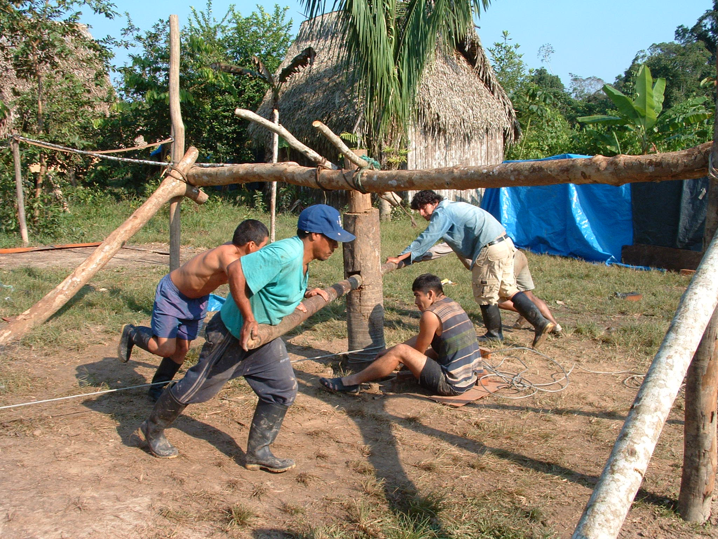
Figure 3. A Peruvian brigada uses a molinete to move timber (Image: Salisbury, 2007).

Moving logs to stream banks is extremely laborious, and these rudimentary mechanical techniques only minimally enhance brute human strength (White, 1978). It is a dangerous job and the International Labor Organization has reported that loggers suffer higher fatality and injury rates compared to workers in other dangerous industries (Putz et al, 2008). Many workers develop hernias and muscle injuries from pushing heavy logs for kilometers through the forest (Salisbury, 2007). Reliance on human labor means timber is sometimes left rotting in the forest because brigadas do not have sufficient labor capacity to move the large quantities of wood they harvest (De la Rosa Tincopa, 2009). Dangerous felling activities can also cause injury or death. Brigadas often do not use directional felling techniques, which can make felling trees very hazardous. Inexperienced chainsaw operators can also make costly mistakes when harvesting timber that jeopardizes the safety of felling crews (White, 1978; De la Rosa Tincopa, 2009).
Labor-intensive timber extraction usually takes about six months (De la Rosa Tincopa, 2009). During this time, brigadas live in logging camps deep within the forest. To construct these camps, the forest is first cleared to create an open space for the camp (White, 1978; De la Rosa Tincopa, 2009). Workers construct huts and a small kitchen from “poles, vines, air roots, and palms,” creating roofs, wooden floors, and sleeping platforms (White, 1978: 403). While loggers may bring crops such as “cocona, cassava, herbs, and chilis” to plant at their camps, they also forage in the surrounding forest for food resources (De la Rosa Tincopa, 2009: 103; White, 1978). The mitayero, or the hunter and cook of the camp, is responsible for providing meat for the brigada while they are in the forest, and also forages for edible palms, sap from tree milk, and beehives (De la Rosa Tincopa, 2009; White, 1978). Brigadas make use of every available resource surrounding their camps, efficiently living off the forest and small amounts of crops during their logging tenure.
With no systems of roads or railroads available, loggers completely rely on streams and rivers to transport timber (White, 1978). Most harvestable timber close to large tributaries has already been cleared by earlier logging operations. Valuable trees are therefore usually found on smaller tributaries and headwaters, which only rise to adequate levels for transporting logs during the rainy winter season (White, 1978; De la Rosa Tincopa, 2009). After moving logs to stream banks, brigadas work to clear tributaries of trunks and other debris so that timber can float freely down streams and rivers during winter flash floods (White, 1978; De la Rosa Tincopa, 2009). Once tributaries are cleared and waters begin to rise during the rainy season, workers lever and drop the timber into the water, buoying the logs together into large rafts (De la Rosa Tincopa, 2009; Salisbury, 2007). A worker, called the tanganero, floats with the logs through their entire fluvial transport, which can be a hazardous and dangerous job (De la Rosa Tincopa, 2009). Debris can overturn or split log rafts in an instance and other logging operations may try to poach logs (Salisbury, 2007). These dangers make the job of floating with log rafts one of the most important in the entire brigada. It is the tanganero’s express job to make sure the logs reach their designated destination.
Overall, selective logging is taxing on both workers and local environments. The drain of timber resources not only makes selective logging unsustainable, but it also substantially affects the biodiversity and ecological integrity of the rainforest. Since local communities in the Peruvian Amazon depend heavily on logging for their livelihoods, it is important that timber stocks remain viable for harvesting for generations to come. Dependence on timber products will force communities to adopt sustainable forestry techniques or risk losing their source of income. Changes in logging techniques do not come easily, however, as the intact selective logging system described above and the expansive physical geography of the Peruvian Amazon make it difficult for sustainable forestry techniques to become widely implemented (Putz et al., 2008).
IV. Impact of Physical Geography on Selective Logging
The diverse and remote landscapes of the Peruvian Amazon distinctly affect the selective logging system. The previous section describes selective logging as a brutal and demanding process, and the extreme physical geography of the Peruvian Amazon only makes logging more difficult. The ecology of the Peruvian Amazon is very heterogeneous, housing thousands of different plant and animal communities. Fairly warm year round, the rainforest is seasonally dominated by changes in precipitation. The rainy season is generally from January to May and the dry season is from June to December, although this may vary throughout the Amazon (De la Rosa Tincopa, 2009). This seasonality distinctly affects water levels in the region and during the dry season some of the smaller tributaries dry up, making many areas inaccessible in the Amazon’s rugged topography. Accurate and up to date maps of this region do not exist, and there is a fundamental lack of knowledge about its physical geography and ecological make-up (Salisbury, 2007). The expansive geographic and ecological heterogeneity of the Peruvian Amazon make establishing and maintaining a profitable logging operation, as well as monitoring logging impacts, a difficult task.
Most easily accessible timber stocks have already been harvested, and logging operations have to travel farther up tributaries and headwaters to reach untapped timber resources. These long distances are often only traveled when the value of the species extracted will pay for the cost of extraction (De la Rosa Tincopa, 2009). This isolation exacerbates the difficulties of transporting wood to market, and the lack of roads makes it costly to transport brigadas and necessary materials upstream to the commercial stands (White, 1978; De la Rosa Tincopa, 2009). In this way, the isolated geography of the Peruvian Amazon acts as a significant restraint on the expansion of logging operations. As the demand for hardwood species continues to increase, however, loggers have greater economic incentives to travel farther into the forest to find remaining commercial stands (Salisbury, 2007).
Besides the relative isolation of most areas in the Peruvian Amazon, some of the most desirable species, such as Swietenia macrophylla (big-leaf mahogany), Cedrela odorata (tropical cedar), and Calyeophylum spruceanum (shihuahuaco), also tend to be widely scattered throughout the forest. The Peruvian Amazon’s “extreme heterogeneity” in flora composition makes it hard to find and mark commercial tree species, as well as transport timber out of the forest (White, 1978: 403). Most commercially valuable tree species occur in low-density populations with usually less than one commercial tree per hectare (Grogan et al., 2008). They generally are secondary-growth species with wind- or water-dispersed seeds that require canopy disturbance for optimal seedling growth (Grogan et al., 2008). Logging crews must spend a lot of time finding and identifying commercial trees and the low-density of valuable trees makes it difficult for logging operations to achieve economies of scale (White, 1978). A greater number of skid trails also have to be constructed in order to move these widely dispersed trees out of the forest, and, without prior planning, this construction can be inefficient, expensive, and time-consuming (Holmes et al., 2000; Putz et al., 2008).
Once logging crews get timber to stream banks, the success of logging operations depend entirely on fluvial transport (White, 1978). Seasonality of stream flows directly influences logging operations, affecting when felling and transport take place. In the “summer season” when it is dry, la corta, or felling, takes place. The dry weather allows the logs to be easily felled and bucked (De la Rosa Tincopa, 2009). In the rainy, or “winter season,” the logs are moved from the forest and transported down tributaries to markets. Without elevated water levels in the rainy season, most tributaries do not have high enough water levels to float timber which making timber extraction in isolated areas impossible. In this way, the seasonality and physical geography of the Peruvian Amazon has a distinct impact on the schedule of logging operations.
The physical geography of the Peruvian Amazon also plays an important role in influencing the environmental impacts of selective logging. In order to improve the sustainability of logging operations, loggers must overcome the limitations imposed by the physical geography of the region, as well as understand how this geography directly influences the environmental impacts of logging.
V. Environmental Impacts of Selective Logging
While the physical environment of the Peruvian Amazon greatly impacts selective logging operations, logging is extremely disruptive to forest ecosystems. Removing even a few trees per hectare can distinctly change forest structure and drastically affect ecosystem functions (Uhl & Vieira, 1989). The large percentage of specific trees harvested by selective logging compromises the viability and regeneration of key commercial species. These species’ already low densities of populations, as well as extremely slow growth rates, means regeneration of key tree species takes a long time. This slow regeneration is further exacerbated by “low seed production rates and supra-annual production cycles, dispersal limitations, pre- and post-germination seed mortality factors, and high seedling mortality in the forest understory beneath closed canopies” (Grogan et al., 2008: 278).
Logging operations also cause substantial damage to non-target species and residual stands (Krueger, 2004). Due to the massive size of trees being harvested, felling causes damage to surrounding trees’ crowns (Uhl & Vieira, 1989). Clearing for felling operations, as well as the construction of skid roads, uproots and destroys many other trees (Jackson et al., 2002; Uhl & Vieira, 1989). Other non-target trees also suffer bark damage during felling (Jackson et al., 2002; Uhl & Vieira, 1989). In one case it was found that, even though only two percent of trees were harvested in a forest concession, 26 percent were killed or damaged during the process (Uhl & Vieira, 1989). Mature, fruit-bearing trees are also harvested without any consideration for their reproductive potential, and without thought to the fact that they are food sources for many other forest animals (Uhl & Vieira, 1989). Hunting by logging crews also distinctly impacts ecosystem composition and the largest and most desired game almost poached to local extinction in forest tracts during logging operations (De la Rosa Tincopa, 2009).
Canopy gaps created through selective logging have some of the largest impacts on forest structure and ecosystem services. Key processes, such as photosynthetic rates, canopy energy and water balance, insect and mammal dynamics, and population dynamics are directly affected by the creation of canopy gaps (Asner et al., 2006). Selective logging tends to be high-impact and opens large canopy gaps (Asner et al., 2006). These large gaps allow light-demanding weeds, such as lianas, to invade what was once dense forest (Putz et al., 2008). Because of successional growth, “larger clearings have faster proportional rates of recovery than smaller clearings, but they require substantially more time to reestablish their full canopy cover” (Anser et al., 2006: 12948). Increased desiccation and wind turbulence in canopy gaps can also lead to tree mortality and damage (Laurance, 1998).
Most notably, however, canopy gaps increase the forest’s susceptibility to fires (Asner et al., 2006). While intact rainforests are usually fairly fire resistant, fragmented sections of forest or sections with many canopy gaps are very vulnerable to fires during dry periods (Laurance, 1998). Drought conditions associated with El Niño can cause huge forest fires to sweep through the rainforest, like the fires that burned an estimated 3.4 million hectares of rainforest in the Amazonia state of Roraima from 1997 to 1998 (Laurance, 1998). Once a section of rainforest burns once, the forest becomes more prone to subsequent fires because trees previously killed by fires act as fuel (Laurance, 1998). The opening of canopy gaps can change ecosystem functions, open areas for invasive species, and increase the susceptibility of fire, all of which have large impacts on rainforest composition and structure.
Mechanized and natural infrastructure associated with selective logging also affects the composition and structure of rainforests. Logging camps stress the surrounding environment, as workers rely heavily on forest resources when working in the field and often over-exploit edible resources to the point of local extinction (De la Rosa Tincopa, 2009). These changes in species composition threaten the viability and resilence of the forest ecosystem (Uli & Vieira, 1989). Soil distribution can also effect species composition, changing the chemical and physical fertility of the soil (Harnato et al., 2003). The construction of roads, skid trails, and bridges by removing vegetation greatly disturbs soil and makes it more susceptible to erosion. Although leaf litter may mitigate some soil erosion, skid trails are a main source of sediment erosion in rainforests because soils can wash directly down pathways into tributaries (Hartanto et al., 2003). On-site erosion, through loss of topsoil, impacts the productivity of the land, which directly alters plant species composition (Haranto et al., 2003). Off-site erosion increases sedimentation and turbidity in surrounding waters, and diminishes water quality (Haranto et al., 2003).
Road construction associated with timber transportation also increases the probability of anthropogenic impacts reaching isolated areas of the Peruvian Amazon. Deforestation, or complete clear-cutting of forests, is most likely to occur within 25 kilometers of main roads because roads increase accessibility to isolated areas (Asner et al., 2006). This encourages colonization, and tracts of rainforest are cleared and burned for agricultural and home sites (Putz et al., 2000). This rapid forest conversion results “from internationally funded development projects, government-sponsored colonization schemes, cattle ranching, small-scale farming, logging, and land speculation” and can completely destroy tracts of rainforest (Laurance, 1998: 412).
Selective logging has immense environmental impacts on Peruvian Amazon. Poor planning, dated techniques, and little regard for the environment makes selective logging unsustainable in the long run. Overall, however, there are few incentives to encourage loggers to reduce the environmental impacts of their operations. In order to improve the long-term sustainability of logging in the Peruvian Amazon by maintaining biodiversity and timber yield, a greater effort must be made to integrate environmental management into the selective logging system.
VI. Improvements to Logging and Forestry Management in the Peruvian Amazon
The Peruvian Amazon’s economic and ecological functions make it an integral resource for local and international communities. While international communities are often interested in luxury items from the rainforest or in its carbon sequestration capabilities, logging communities within the Peruvian Amazon depend on forest resources for their livelihoods. Those responsible for depleting forest resources therefore have a vested interest in developing and implementing sustainable logging system that helps to maintain forest resources. Currently, however, only about 3.5% of permanent forest estates are managed sustainably (Putz et al., 2008). Much can be done to improve the effectiveness and efficiency of selective logging systems throughout the Peruvian Amazon. Reduced-impact logging (RIL), “intensively planned and carefully controlled timber harvesting conducted by trained workers in a way that minimizes the deleterious impacts of logging,” along with other sustainable forestry techniques offer feasible ways to combine logging with local stewardship and sustainable extraction (Putz et al., 2008: 1428).
Thorough pre-planning is the first and most important step of RIL. Detailed inventories of the trees to be harvested are created. Commercial trees are “mapped, marked and measured” and skid roads are planned in advance of logging operations for the most efficient extraction of wood (Putz et al., 2008: 1428; Holmes et al., 2002; Uhl et al., 1989). During this process sawyers can adequately examine trees, looking for defects, lean, or height issues that might jeopardize the harvesting process (Holmes et al., 2002). Flawed trees are then excluded from the harvesting map and left intact in the forest. RIL sustainability could be improved if future crop trees (FCT) were also mapped and mature or fruiting trees were excluded from harvesting in order to leave adequate stands for regeneration and to maintain timber yields (Putz et al., 2008; Peña-Claro et al., 2008). Proper skid trail planning can reduce soil disturbances, which protects future forest productivity, as fewer trees are destroyed during harvesting operations and less mineral soil is exposed (Holmes et al., 2002).
The success of this pre-planning, however, depends on the availability of detailed geographic and ecological data. The expanse and remoteness of the Peruvian Amazon makes it hard to measure the effects of selective logging, and little is known about its extent and impact (Asner et al, 2006). Labor-intensive field surveys are often required for objective and accurate reporting of selective logging, but these methods are costly, time-consuming, and can be dangerous in highly contested areas (Asner et al, 2006). Large-scale data collection and mapping, however, is vital for developing accurate pre-harvest plans for sustainable logging. Remote observation and data collection offers an effective and efficient way to monitor the effects of selective logging and gather spatial information for pre-harvest logging plans.
By using remote sensing to pinpoint commercial trees and map the topography and physical geography of the logging area, forest managers can determine possible ecological effects of logging operations and develop better plans to mitigate these impacts. Pre-harvest plans can minimize the effects of logging activities by efficiently placing skid trails to avoid areas with difficult topography, as well as guide harvesting procedures and logging camp placement (Putz et al., 2008). Access to this type of ecological information will also help forest managers determine how many trees should be harvested of various species populations, ensuring sustainable harvests allow for future regeneration of timber stock. Roy Glib’s paper, Assessment and Future Prospects of Remote Sensing Techniques to Evaluate Forest Damage in the Peruvian Amazon, further discusses the benefits of large-scale, remote data collection, highlighting its essential importance in future sustainable logging activities.
While remote data collection and mapping offers an effective way to model and monitor the environmental impacts of selective logging and other forestry techniques, technological limitations may force logging teams to use in-the-field monitoring and data collection. The immense ecological diversity and heterogeneity of the rainforest make it difficult to monitor environmental impacts of logging, as different species may have different responses to logging disturbances (Putz et al., 2008). Monitoring a few, objective environmental indices and mitigating their effects will make RIL training and implementation more feasible in the field if in-depth pre-planning cannot occur. Things such as minimizing canopy gaps, minimizing the amount of forest opened for skid trails, and taking into account slope, can be easily monitored in the field and can help to sustain forest yields, reduce deleterious environmental impacts of logging, and maintain biodiversity (Uhl et al., 1989). Ethan Strickler’s paper, Diversity, Disturbance, Ecology, and the Ecological Characteristics of Commonly Exploited Timber Species—Recommendations for Peruvian Forestry, discusses important ecological factors that influence commercial tree species in the Peruvian Amazon, and how these ecological characteristics may be integrated into forestry management plans. Using environmental indices as on-site indictors for logging operations, in addition to RIL techniques, will be critical for successful sustainable logging in the Peruvian Amazon.
RIL management for minimal environmental impact, however, sometimes directly conflicts with maintaining timber yields and sustainable forest management (Fredericksen & Putz, 2003). The depletion of timber resources is often a factor of the frequency of extraction, rather than environmental disturbances of logging (White, 1978). Forests with residual stands of commercial seedlings and saplings may be able to maintain timber yields with RIL techniques that minimize harvesting impacts to FCTs. Forests that require greater regeneration of commercial species, however, may require greater disturbances than those created during RIL logging to allow the for the growth of commercial trees (Fredericksen & Putz, 2003). Silvicultural treatments, such as removing lianas, overtopping trees, and weed control, can positively affect the growth rates of FCTs and can help to improve commercial stock regeneration (Peña-Claro et al., 2008; Fredericksen & Putz, 2003; Uhl et al., 1989). Disturbances may also increase species diversity, allowing successional plant species to grow in areas where climax species had originally outcompeted them (Fredericksen & Putz, 2003). “Abundance and diversity of many wildlife taxa,” such as tapirs, some birds, and some primates, has also been shown to increase in logging gaps (Fredericksen & Putz, 2003). The conservation of biodiversity and FCTs in the Peruvian rainforest will therefore depend on integrating biodiversity protection strategies and logging systems (Fredericksen & Putz, 2003).
While maintaining biodiversity and timber yields is important to international communities for intrinsic value and specialty commodities, many local communities depend on forest resources for their livelihoods. Community empowerment and stewardship, therefore, is one of the most important aspects of successful sustainable forestry management. Strengthening community and indigenous land rights will create interested and involved small-scale forest managers who are invested in maintaining sustainable logging operations in order to support their families. Legalizing and cementing property rights for local groups means communities will be directly dependent on the profitability of their forested land. This shifts local communities’ focus to maintaining the long-term profitability of logging, rather than viewing the forest as a disposable resource (Putz et al., 2008). Reducing environmental impacts of logging and maintaining FCTs thus becomes logical management practice in order to maintain profitability (Putz et al., 2008). Property rights will also allow forest managers to take advantage of non-timber forest resources. This economic diversification with other resources like cultural amenities, ecotourism opportunities, and environmental service payments lessens community reliance on logging and offers a way to develop sustainable economies based on the harvest and management of timber and non-timber resources (Putz et al., 2008; Barros & Uhl, 1995). Will Gordon’s paper, The Importance of a Formal Property System in Peru, explores ways securing local communities’ property rights may help reduce deforestation, showing how ownership and stewardship of the forest gives local communities incentive to protect and preserve it.
RIL techniques also call for investment in specialized training for brigadas. This investment in “human capital” can help to further empower local workers by giving them marketable skills and professional status, as well as increasing their ecological knowledge of the rainforest (Holmes et al., 2000). This training is intended to reduce costs due to wasted wood, as well as increase efficiency of machinery use, decrease ecological impacts, and decrease worker risks (Holmes et al., 2002; Putz et al., 2008). In selective logging operations, workers receive on-site training that does little to protect them from the dangers of felling massive trees. The training also does not educate them about the best way to minimize environmental impacts. In this way, RIL training gives local workers information and training to reduce harvesting impacts. It also decreases logging costs, by improving harvesting efficiency. RIL training provides lifelong professional skills, which local loggers can use to improve their job prospects and share with their communities.
Many logging operations, however, are apprehensive about switching to RIL for fear of potential economic burden (Putz et al., 2008). Incremental costs, such as investing in new equipment and worker training, as well as adopting new harvesting techniques and hiring qualified forest managers, are costs that selective logging operations do not have to take into account (Putz et al., 2008; Pokorny et al., 2005). While there may be start-up costs associated with RIL, in most instances RIL does not prove to be significantly more expensive then selective logging (Figure 4) and can sometimes be more profitable than selective logging (Holmes et al., 2000). Selective logging operations have been found to miss as much as 20% of harvested wood when removing logs from the forest (Richter, 2002). This oversight results in large financial losses for loggers, which are further amplified by inefficient logging practices that generate large amounts of waste wood (Putz, et al., 2008). By using RIL planning techniques, logging operations can reduce waste and successfully export logs out for the forest through well-organized harvesting techniques and pre-planned skid trails. Extensive pre-harvest inventories can also allow loggers to establish forward contracts with mill owners. These contracts help make sure harvested trees will be bought, eliminating low prices associated with sitting product and overharvest (Holmes et al., 2000). In order to make RIL a realistic option for logging operations, however, loggers need to be educated about the RIL and sustainable logging practices and their potential financial benefits.
Activity | Conventional (Selective) logging (US$ per m³) | Reduced impact logging  (US$ per m³) | Difference:  RIL-CL
Pre-harvest | 0.00 | 1.18 | 1.18
Harvest planning | 0.14 | 0.16 | 0.00
Infrastructure | 0.57 | 0.59 | 0.02
Felling and bucking | 0.49 | 0.62 | 0.13
Skidding | 1.99 | 1.24 | -0.75
Log deck operations | 2.01 | 1.28 | -0.73
Waste adjustment | 0.40 | 0.09 | -0.31
Stumpage cost | 9.09 | 7.61 | -1.48
Training | - | 0.21 | 0.21
Overhead/support | 0.97 | 0.86 | -0.11
Total cost | 15.66 | 13.84 | -1.82
Gross returns | 25.50 | 25.50 | 0.00
Net revenues | 9.84 | 11.66 | 1.82
Figure 4. These numbers, from a study in Brazil in comparing selective logging and RIL, show that RIL does not actually cost more than selective logging. In some instances RIL may have less total costs and produce greater net revenues than selective logging (Figure: Holmes et al., 2002).

In order to maintain timber yields in the Peruvian Amazon, sustainable logging needs to become the standard for forest management. The feasible application of sustainable logging practices will only be possible with the integration of a number of different sustainable forestry practices and the current logging norm. Pre-harvest planning, remote monitoring, ecological studies, and community empowerment and education are all important steps that will decrease environmental impacts of logging and help to maintain timber yields and biodiversity in the Peruvian Amazon.
VII. Conclusion
Sustainable management of rainforest logging operations has typically failed to become widespread practice in the Peruvian Amazon (Uhl et al., 1991). Low densities of commercially harvestable wood in rainforests make it hard to maintain sustainable economies of scale; the costs associated with implementing RIL make loggers unwilling to change their selective logging techniques; pre-planning takes time and money; and local communities are trapped in debt peonage systems (Uhl et al., 1991; White, 1978; Salisbury 2007, De la Rosa Tincopa, 2009). The livelihoods of communities, conservation of biodiversity, and maintenance of timber yields in the Peruvian Amazon, however, depend on the successful integration of sustainable and selective logging.
In order to develop an efficient and effective sustainable forestry system, it is important understand the current logging norm. Most current sustainable forestry research focuses exclusively on RIL or other sustainable harvesting techniques, emphasizing only the scientific rationale and urgency behind implementing these practices. Papers fail to address the current logging norm, instead advocating the importation of an entirely new system of forestry management. By ignoring selective logging, researchers and sustainable forestry advocates are disregarding a system that is the economic and social backbone for many communities in the Peruvian Amazon. The successful implementation of sustainable logging practices will only come with the acknowledgement and integration of selective logging within the framework of sustainable forestry.
The incorporation of selective and sustainable logging must be a dynamic process. No single sustainable forestry system will be applicable throughout the entire Peruvian Amazon and local community participation will be vital to the success of sustainable forestry. The extreme heterogeneity of the forest’s ecology and geography and the diverse needs of local communities means individualized sustainable forestry plans will need to be developed for logging sites. Detailed data provided by remote monitoring, informed maps, and a better understanding of unique ecological components of specific logging sites can help guide and expedite the planning process. The decentralization of forestry management will allow local communities to be more involved in forestry planning processes. This participation in sustainable logging planning will promote education within Peruvian logging communities about the shortsightedness of ill-planned selective logging. By educating local communities about the destructive impacts of selective logging on timber resources, local environments, and livelihoods, they can become better forest stewards, spearheading the integration of sustainable logging practices into the current logging norm.

VIII. Bibliography
Asner, G. P., Broadbent, E. N, Oliveria, P. J. C., Keller, M., Knapp, D. E., & Silva J. N.
M. (2006). Condition and fate of logged forests in the Brazilian Amazon. PNAS 103(34): 12947-12950.

Barros, A. C. and Uhl., C. (1995). Logging along the Amazon River and estuary:
Patterns, problems, and potential. Forest Ecology and Management 77: 87-105.

De la Rosa Tincopa, C. (2009). Environmental governance and implications of small-
scale logging: the case of the indigenous groups in the Ampiyacu Basin in the Northeastern Peruvian Amazon. (Thesis). The University of Texas, Austin.

Fredericksen, T. S. & Putz, F. E. (2003). Silvicultural intensification for tropical forest
conservation. Biodiversity and Conservation 12: 1445-1453.

Grogan J., Jennings, S. B., Landis, M. R., Schulze, M., Baima, A. M. V., Lopeze, J. do C.
A., Norghauer, J. M., Oliveria, L. R., Pantoga, F., Pinto, D., Silva, J. N. M., Vidal, E., & Zimmerman, B. L. (2008). What loggers leave behind: Impacts on big-leaf mahogany (Swietenia macrophylla) commercial populations and potential for post-logging recovery in the Brazilian Amazon. Forest Ecology and Management 255: 269-281.

Haranto, H., Prabhu, R., Widayat, A. S. E., Asdak, C. (2003). Factors affecting runoff
and soil erosion: plot-level soil loss monitoring for assessing sustainability of forest management. Forest Ecology and Management 1-3: 361-374.

Holmes, T. P., Blate, G. M, Zweede, J. C., Pereira, Jr., R., Barreto, P., Boltz, F., &
Bauch, R. (2000). Financial costs and benefits of reduced-impact logging relative to conventional logging in the Eastern Amazon. Latin American and Caribbean (LAC) and Global Bureaus of USAID. Retrieved from http://pdf.usaid.gov/pdf_docs/Pnacp360.pdf.

Holmes, T. P., Blate, G. M, Zweede, J. C., Pereira, Jr., R., Barreto, P., Boltz, F., &
Bauch, R. (2002). Financial costs and benefits of reduced-impact logging relative to conventional logging in the Eastern Amazon. Forest and Ecology Management 163: 93-110.

Huhsunqu. (2009). File: Peru- Regions and departments (labeled). Wikimedia Commons.
Retrieved from http://commons.wikimedia.org/wiki/File:Peru_-_Regions_and_departments_(labeled).svg.

Jackson, S. M, Fredericksen, T.S., & Malcolm, J. R. (2002) Area disturbed and residual
stand damage following logging in a Bolivian tropical forest. Forest Ecology and Management 166(1-3): 271-283.

Kopp, K. (2011). Tracer, Traceable Certified Forest Products. Retrieved from:
http://www.tracer.dk/index.php?id=10&nid=56.

Krueger, W. (2004). Effects of future crop tree flagging and skid trail planning on
conventional diameter-limit logging in a Bolivian tropical rainforest. Forest and Ecology Management 188(1-3): 381-393.

Laurance, W. F. (1998). A crisis in the making: responses of Amazonian forests to land
use and climate change. TREE 13(10): 411-415.

Peña-Claro, M., Fredericksen, T. S., Alarcón, A., Blate, G. M., Choque, U., Leaño, C.,
Licona, J. C., Mostacedo, B., Pariona, W., Villegas, Z., & Putz F. E. (2008). Beyond reduced-impact logging: Silvicultural treatments to increase growth rates of tropical trees. Forest Ecology and Management 256: 1458-1467.

Pearce, D., Putz, F. E. and Vanclay, J. K. (2003). Sustainable forestry in the tropics:
panacea or folly?. Forest Ecology and Management 172: 229-247.

Pokorny , B., Sabogal, C., Silva, J. N. M., Bernardo, P., Souza, J., & Zweede, J. (2005).
Compliance with reduced-impact harvesting guidelines by timber enterprises in the terra firme forests of the Brazilian Amazon. International Forest Review, 7: 9-20.

Putz, F. E., Dykstra, D. P., & Heinrich, R. (2000). Why poor logging practices persist in
the tropics. Conservation Biology 14(4): 951-956.

Putz, F.E., Sist, P., Frederickesen, T., & Dykstra, D. (2008). Reduced-impact logging:
challenges and opportunities. Forest Ecology and Management 256: 1427-1433.

Richter, F. (2002). Financial and economic assessment of timber harvesting operations in
Sarawak, Malaysia. Forest and Harvesting Case Study 17. Food and Agriculture Organization of the United Nations, Rome.

Salisbury, D. (2007). Overcoming marginality on the margins: Mapping, logging, and
coca in the Amazon borderlands. (Doctoral dissertation). The University of Texas, Austin.

Uhl, C. and Vieira, I. C. G. (1989). Ecological impacts of selective logging in the
Brazilian Amazon: A case study from the Paragominas region of the State of Para. Biotropica 21(2): 98-106.

Uhl, C., Veríssimo, A., Mattos, M. M., Brandion, Z., & Vieira, I. C. G. (1991). Social,
economic, and ecological consequences of selective logging in an Amazon frontier: the case of Tailândia. Forest Ecology and Management 49: 243-273.

White, S. (1978). Cedar and mahogany logging in Eastern Peru. Geographical Review
68(4): 394-416.

