**PLSC 379: Critical Race Theory**

**SPRING 2024: TUESDAY-3-5:45 pm**

**CLASSROOM: Weinstein 209**

**Andrea Y. Simpson, Instructor**

**Office: 202 K Weinstein Hall**

**Office Hours: By appointment**

**Office Phone- 804-289-8739**

**Email:** [**asimpson@richmond.edu**](mailto:asimpson@richmond.edu)

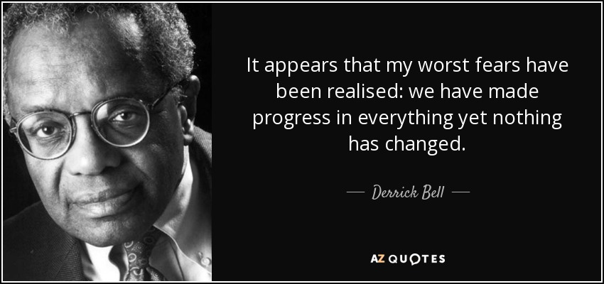

Over thirty years ago, an intellectual movement began that had roots in the field of critical legal studies.[1] This movement, Critical Race Theory (CRT), evolved into an expansive field of study that includes analysis from a number of scholars that represent other minority groups. Other disciplines are engaged in the methodological innovations of CRT.

CRT advances two central intellectual and political commitments: One is that the liberal legal tradition fails to consider how laws, for example civil rights legislation, reconstitute systemic and institutional racism. The second is that while law is a powerful tool, it has not been able to address structural and institutional racism. Our learning goals are as follows:

* Develop a sophisticated understanding and knowledge of CRT
* Learn how to engage with the concepts and methods to produce independent and original research.

**Texts**

***Critical Race Theory (Third Edition): An Introduction* (Critical America, 20) 3rd Edition**

by Richard Delgado, Jean Stefancic, Angela Harris (Foreword), NYU Press.

***Faces At the Bottom of The Well*,** by Derrick Bell

***Racism without Racists: Color-Blind Racism and the Persistence of Racial Inequality in***

***America*,**by Eduardo Bonilla-Silva

***The Nickel Boys***, Colson Whitehead

**Assignments and Grades**

Paper-25%-Students will write a 10–12-page paper which wil be a critical analysis of a rule, policy, or process that exists at the University of Richmond. University policies are the same as laws. Do any of our policies or process hurt one group of people more than other groups?

Midterm-25%-This will be an in-class midterm taken on your laptop. This is an essay exam that requires that you synthesize the principles of CRT and can apply them to specific examples.

Attendance, Class Participation-25%- This class is particularly dependent on the quality of our class discussions. If you are not here, you cannot participate.

Blog postings-25%- The blog postings are a basis and extension of the readings and our class discussions.

**A full 50 percent of your grade is determined by attendance, participation, and the quality of your postings to the Course Blog.**

**Blog Postings Schedule**

Our class is held once a week. A student will be assigned each week to comment on the readings for that week. This will begin the second week of classes. You are to post 500 words on the readings. Remember that posing questions is as important as making observations. That posting is due every Friday by 5:00 pm.

Each student must post a 250-word response to the original posting by Saturday.

**Paper and Writing Expectations**

My standards for writing are rigorous. I will assess your writing based on clarity, organization, word usage, and sentence construction. You should have a clear understanding of baseline standards in these areas. I plan to edit carefully each assignment, including in-class writing assignments, for spelling, punctuation, and grammatical mistakes. I strongly you recommend a good writing book My favorite tools are *On Writing Well*, by William Zinsser and *Woe Is I* by Patricia T. O’Connor. Other excellent writing tools are: *Eats, Shoots, and Leaves*: *The Zero Tolerance Approach to Punctuation* by Lynn Truss and *Elements of Style* by William Strunk, Jr.

Remember that running a “spell check” through your Word program is not the same as proofreading your work. Some students find it helpful to read their papers aloud to find errors. Please seek help from the Writing Center and other resources listed on the blog. I am available for consultation via email, during office hours, and by appointment.

* Personal experiences and observations do not carry as much weight as an academic publication. Anecdotes and stories can illuminate, but they are no substitute for hard research, whether it is qualitative or quantitative.
* Avoid the temptation to write something you think I will agree with—you cannot be sure of my opinion in this class. During many classes, I will play “devil’s advocate” to spark discussion and to help you to think more critically. Integrity in writing includes writing about something that you believe in, not something that you believe can yield extra points from the professor.
* Format, organization, grammar, spelling, punctuation
* **PLEASE USE THE BLOG FOR RESOURCES ON WRITING A RESEARCH CRITICAL RACE THEORY**

**Use of ChatGPT and Artificial Intelligence Software**

In your written assignments for this course, all work you submit must be entirely your own. Words, sentences, paragraphs, and essays which are the product of AI software, for example, may not be presented as your own work, and doing so is a violation of university policy. As a learning community, we might find ways to use AI to generate thoughts or as a starting point for honing critical thinking skills.

*Part of this statement is reprinted with permission from Dr. Tony Affigne, Professor, Providence College.*

**Late Work**

Turning in late work reflects poorly on you. Please avoid it at all costs. Any late work receives a letter grade deduction for each class period it is late.

**Attendance**

Students are responsible for all information in the class, regardless of their personal attendance. If a student is absent, it is his or her responsibility to inquire about what they have missed. Absences due to university activities (e.g., sports, mock trial, etc.) must be discussed

with the instructor before the relevant class period(s). An official notice must be shown to the instructor. Arrangements concerning absences are entirely at the instructor's discretion.

Please be on time for class to avoid unnecessary disruptions of speeches, lectures, and discussions.

In-Class Participation

“A” for class participation is awarded when students regularly initiate discussion. This means coming to class thoroughly familiar with the assigned reading and, therefore, prepared to raise questions, to open discussion, to identify topics of interest in the reading, and actively engage other students in the discussion. The quality of your blog posts matters. Do your comments expand on the readings or point out interesting aspects? Did you do any additional research to expand on your points? [90-100 points]

“B” for class participation is awarded to students who participate regularly and productively in class discussion, who are prepared, and who are willing to engage. Students who earn “Bs” differ from “A” students in that the latter are self-starters who do not rely on the instructor's questions to set the agenda for discussion. [80-89 points]

“C” for class participation is awarded to those who participate on a regular, but less frequent basis than the B student. Students who earn “Cs” arrive prepared for class, but their contributions will indicate that less thought has been given to assigned materials. [70-79 points]

“D” for class participation is given to those who contribute infrequently to the discussion and whose contributions do not appear to arise from thoughtful consideration of the assignments. [60-69 points]

“F” for non-participation in class discussion. Of course, participation is impossible if you do not attend class. Frequent absences mandate failing grades. [0-60 points]

**Grievance Procedures**

Occasionally, students are unsatisfied with some dimension of the course. In such cases, you should first provide a written argument in support of your position to ProfSi and request a meeting. All grade appeals on specific assignments must be made within one week of the return of the assignment.

**Academic Honesty**

Students are expected to pledge the following statement on all assignments turned in for credits: "I pledge that I have neither received nor given unauthorized assistance during the completion of this work." Academic honesty is the performance of all academic work without cheating, lying, stealing, or receiving assistance from any other person or using any source of information not appropriately authorized or attributed. The University of Richmond and your professors take academic honesty very seriously. The penalties for academic dishonesty are severe and ignorance is not an acceptable defense. For more information visit:

<http://studentdevelopment.richmond.edu/student-handbook/honor/the-honor-code.html>

**Course Schedule**

**Part I. Introduction: What is Critical Race Theory?**

Tue 1.16 Why are we here? What do we want to understand? What do we know?

What do we want to know?

The Controversy

Syllabus Review

Tue 1.23 *Critical Race Theory*, Chapters 1-2

Tue 1.30 “Mapping the Margins,” Crenshaw-**EMMA SETO**

*Critical Race Theory*, Chapters 3-5

**Part II. Critical Race Theory: Key Writings, Application, and Narrative as Methodology**

Tue 2.6 “*Brown v. Board of Education* and the Interest Convergence Dilemma,” on

Blackboard-**GABRIEL MATTHEWS**

Tue 2.13 “The Racial Preference Licensing Act,” “The Chronicle of the Space Traders,”

and “Racial Realism,” in *Faces at the Bottom of the Well.-***KAIDEN PRITCHETT**

**FIRST RESPONSE PAPER DUE TODAY**

Tue 2.20 “The Last Black Hero,” “Devising a Racial Realism Theory” in *Faces at the Bottom*

*of the Well*- **NOAH WASHINGTON**

Tue 2.27 “You Belong to Me,” The Story of Ruby McCollum

**Part III. The Frame and Contours of Contemporary Racism**

Tue 3.5 **Midterm Exam**

**SPRING BREAK: MARCH 9-MARCH 17**

Tue 3.19 *Racism without Racists*, Preface and Chapter 1-3-**Q JEFFRIES**

Tue 3.26 *Racism without Racists*, Chapters 4-8-**TAYLOR HARRIS**

Tue 4.2 *Racism without Racists***,** Chapters 9-11-**DIO SCOTT**

Tue 4.9 *The Nickel Boys*

Tue 4.16 *The Nickel Boys*

Tue. 4.23 What have we learned? What, if anything, does CRT offer for advancing justice?

1. Critical Legal Studies is a School of Critical Theory that emerged in the late 1970s. Scholars in the field challenged the notion that law is neutral. The most controversial assertion of this school was that law, in fact, codified the oppression of the poor and the material interests of the rich. Other aspects included the delineation of the political ends of laws, (legislative), from the judicial ends. CLS casts a critical eye on the function of laws as the protection of individual rights.